**What are some basic examples here?**

Here are a few examples:

* A user can write no more than 2 posts per second.
* You can create a maximum of 10 accounts per day from the same IP address.
* You can claim rewards no more than 5 times per week from the same device.

And then

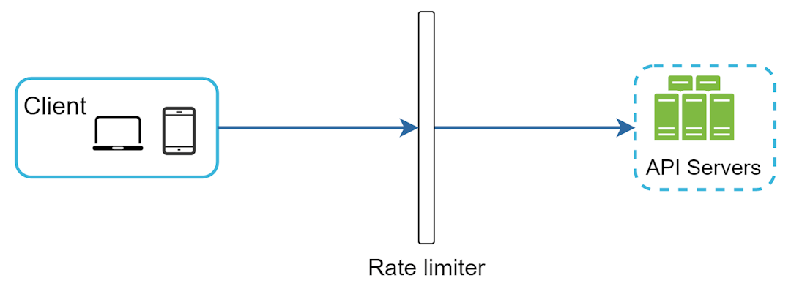

And the above should look like that

1. API gateway here would support all this here,

**Method 1: Using token bucket algorithm here**

. Both Amazon [5] and Stripe [6] use this algorithm to throttle their API requests.

**How many buckets do we need?**

It is usually necessary to have different buckets for different API endpoints. For instance, if a user is allowed to make 1 post per second, add 150 friends per day, and like 5 posts per second, 3 buckets are required for each user.

* A token bucket is a container that has pre-defined capacity. Tokens are put in the bucket at preset rates periodically. Once the bucket is full, no more tokens are added. As shown in Figure 4, the token bucket capacity is 4. The refiller puts 2 tokens into the bucket every second. Once the bucket is full, extra tokens will overflow.

**A tokening alogirhtm here**

1. Each request consumes 1 token, When a request arrives, we check if there are enough tokens in the bucket. Figure 5 explains how it works.
2. f there are enough tokens, we take one token out for each request, and the request goes through.
3. If there are not enough tokens, the request is dropped.

**What are the parameters here?**

* Bucket size: the maximum number of tokens allowed in the bucket
* Refill rate: number of tokens put into the bucket every second

**What’s the pros and cons here?**

Pros:

* The algorithm is easy to implement.
* Memory efficient.
* Token bucket allows a burst of traffic for short periods. A request can go through as long as there are tokens left.

Cons:

* Two parameters in the algorithm are bucket size and token refill rate. However, it might be challenging to tune them properly.

**Leaking bucket algorithm?**

1. And then here

**What’s the token bucket algorithm?**